Ex.No.1 Implementation of Caesar Cipher

Aim:

To implement Caesar cipher using Java

Algorithm:

1. Read the plain text from the user
2. Read the key value as integer from the user for encryption
3. Add the key value for each character in the plain text to get cipher text
4. Print the encrypted text in the screen
5. Use the encrypted text as input for decryption and key value is same but it is considered as negative integer value
6. Subtract the key value from the decrypted text to get the final plain text
7. Print the decrypted text in the screen

Coding:

import java.io.BufferedReader;

import java.io.IOException;

import java.io.InputStreamReader;

import java.util.Scanner;

public class CeaserCipher

{

static Scanner sc=new Scanner(System.in);

static BufferedReader br=new BufferedReader(new InputStreamReader(System.in));

public static void main(String[] args)throws IOException

{

System.out.print("Enter any String:");

String str = br.readLine();

System.out.print(" \nEnter the Key:");

int key = sc.nextInt();

String encrypted = encrypt(str,key);

System.out.println("\nEncrypted String is:"+encrypted);

String decrypted = decrypt(encrypted,key);

System.out.println("\nDecrypted String is:" + decrypted);

System.out.println("\n");

}

public static String encrypt(String str,int key)

{

String encrypted = "";

for(int i=0;i<str.length();i++) {

int c=str.charAt(i);

if(Character.isUpperCase(c))

{

c=c+(key%26);

if(c>'Z')

c=c-26;

}

else

if(Character.isLowerCase(c))

{

c=c+(key%26);

if(c>'z')

c=c-26;

}

encrypted+=(char)c;

}

return encrypted;

}

public static String decrypt(String str,int key)

{

String decrypted = "";

for(int i=0;i<str.length();i++) {

int c=str.charAt(i);

if(Character.isUpperCase(c))

{

c=c-(key%26);

if(c<'A')

c=c+26;

}

else

if(Character.isLowerCase(c))

{

c=c-(key%26);

if(c<'a')

c=c+26;

}

decrypted += (char)c;

}

return decrypted;

}

}

Output:

Enter any String:Hello World

Enter the Key:3

Encrypted String is:Khoor Zruog

Decrypted String is:Hello World

Verification using cryptii.com:



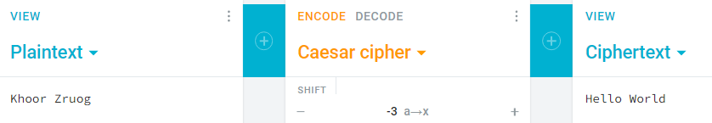

Result:

Thus the Caesar cipher is implemented using Java and is executed successfully and the output is verified using cryptii.com for the same plain text and key values.